Lab 6

3. A baseline model of 1D CNN is constructed and trained on IMDB dataset for 10 epochs displayed as below.
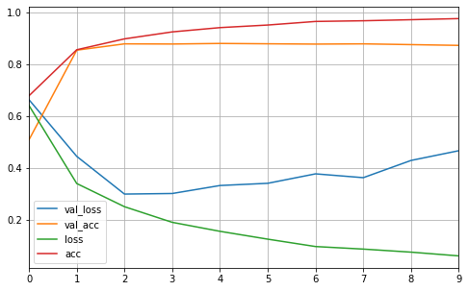

It could be observed that the model begins to overfit after 2-3 epochs with validation loss starting to rise and validation accuracy unchanged. To reduce overfitting, some approaches could be applied such as adding dropout layers, and applying regularizations to limit the complexity of weights.

4. Different combinations of options on dropout and regularization are attempted, and the best one works at a 0.6 dropout rate, and applying both l1 and l2 regularization on the dense layer with penalties set at 0.05 for both. The resulting network performs as below. Now the overfitting has been much reduced.
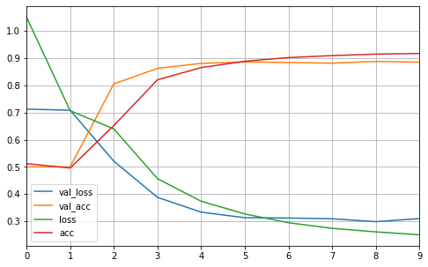

5.

